Future Ready Talent - Project Documentation

Name – Vedant Adya

Project Title – Personality Detection using python and ML

**Project Statement**

**Project Aim**

* Classifying the personality of the user based on the big five personality traits using data mining
* The goal of this project is to build a model that predicts the personality of the people.
* The main aim of the proposed system is to predict the personality of the user by the answers given by the user.

**Description**

* Personality identification of a human being by their nature an old technique. Earlier these were done manually by spending lot of time to predict the nature of the person.
* Methods used to analyze the data include surveys, interviews, questionnaires, classroom activities, shopping website data, social network data about the user experiences and problems they are facing.
* Proposed system will provide information about the personality of the user. Based on the personality traits provided by the user, System will match the personality traits with the data stored in database.

**Azure Services Used –**

Virtual Machine

Azure SQL Database

**Other Services Used –**

Bash Scripts

Network security group

**Environment Used-**

VM – Linux (ubuntu 20.04)

System – Windows 11

**Project Walkthrough**

* **Create an Azure free account, sign into my Azure Portal**
* **Click on virtual machine tab, create virtual machine**

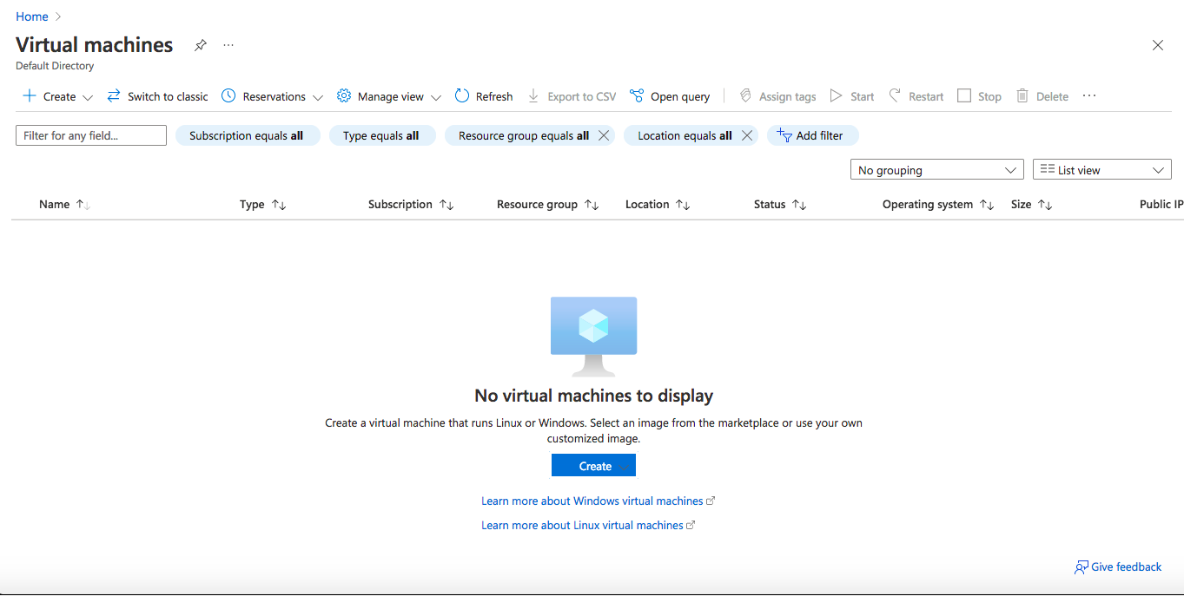

o Subscription- Free Trial

o Resource group- Finalres-group

o Virtual machine name- final-predict-app

o Region- West US 3 (Zone 1)

o Leave disks tab as default

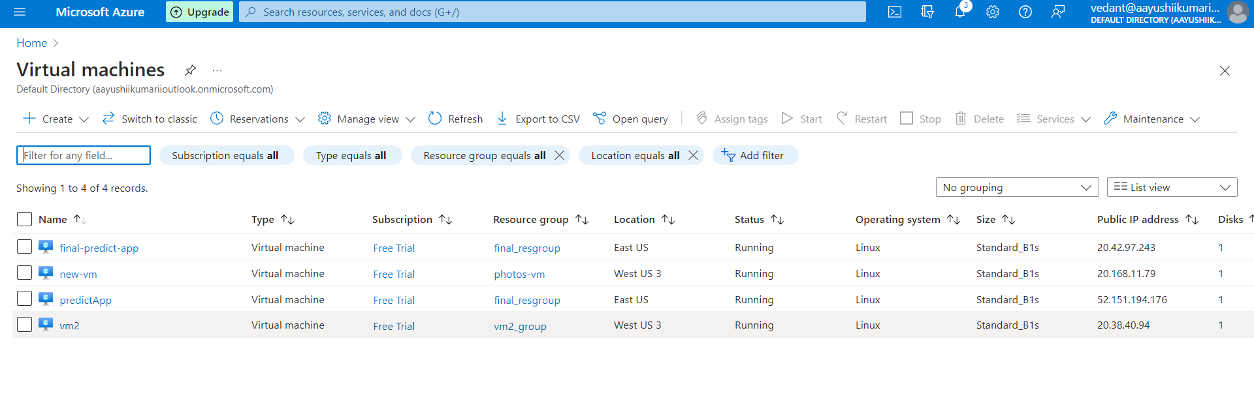

**Connect to virtual machines**

There are several ways to access your Azure virtual machines. The Azure portal supports options for connecting your Windows and Linux machines, and making connections by using Azure Bastion. The following diagram shows how you can connect Azure virtual machines with the SSH and RDP protocols, Cloud Shell, and Azure Bastion.

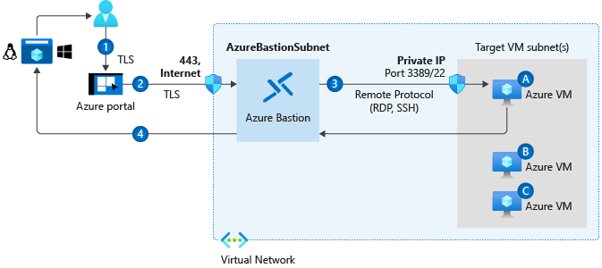

**CREATE A AZURE SQL DATABASE SERVER**

Resource group(move): [final_resgroup](https://portal.azure.com/#@aayushiikumariioutlook.onmicrosoft.com/resource/subscriptions/4f7f032d-b4af-41de-9967-bf51447c8cd0/resourceGroups/final_resgroup)

Status: Running

Location: East US (Zone 1)

Subscription(move):[Free Trial](https://portal.azure.com/#@aayushiikumariioutlook.onmicrosoft.com/resource/subscriptions/4f7f032d-b4af-41de-9967-bf51447c8cd0)

Subscription ID : 4f7f032d-b4af-41de-9967-bf51447c8cd0

Availability zone:1

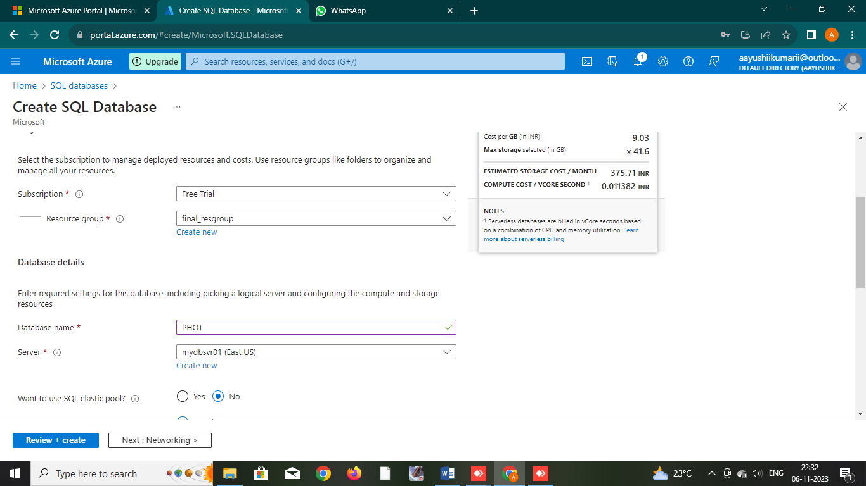

**CONNECT AZURE SQL DATABASE TO WEBSITE**

* 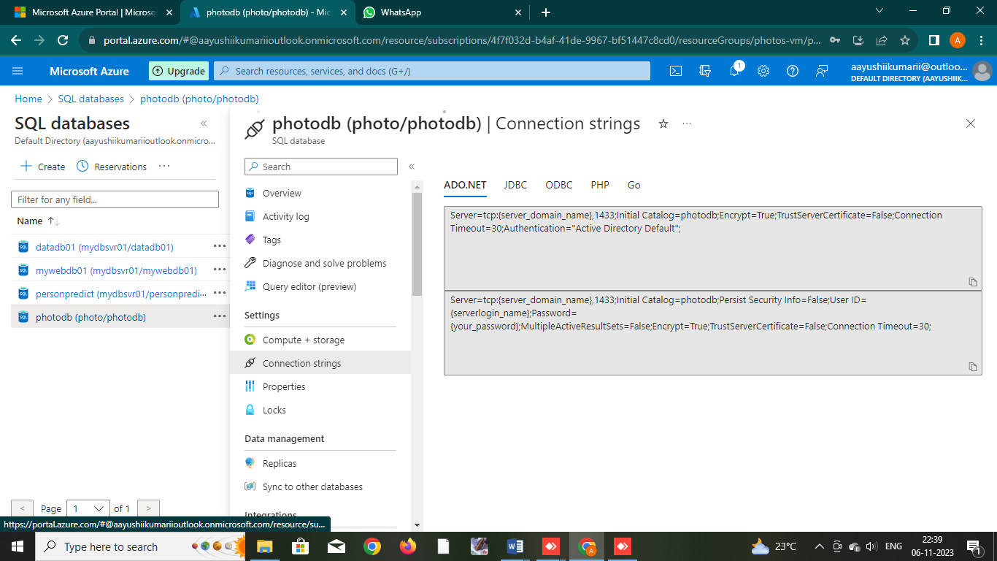First go to connection string

-Then paste the connection string in your code

**NOW CONNECT THE VM SSH USING AZURE CLI**

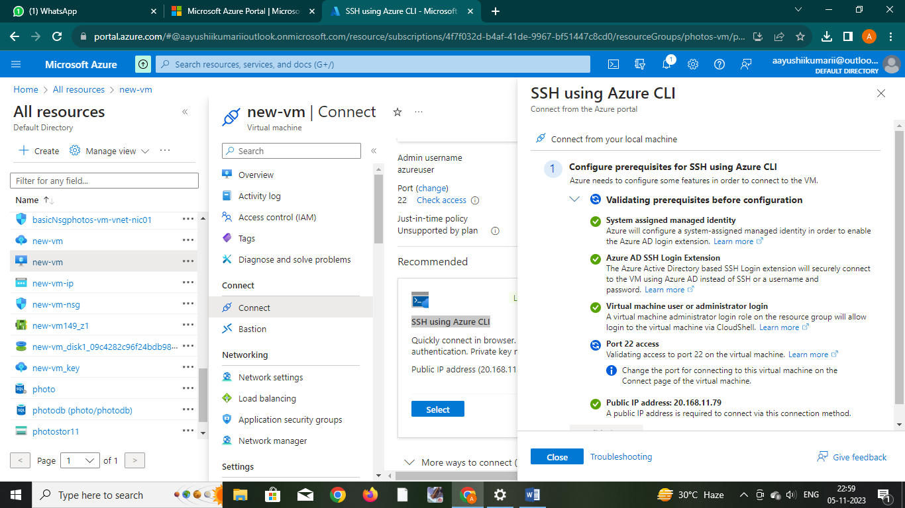

NOW IN TERMINAL WRITE THE COMMAND

1. sudo apt update && sudo apt upgrade –y
2. 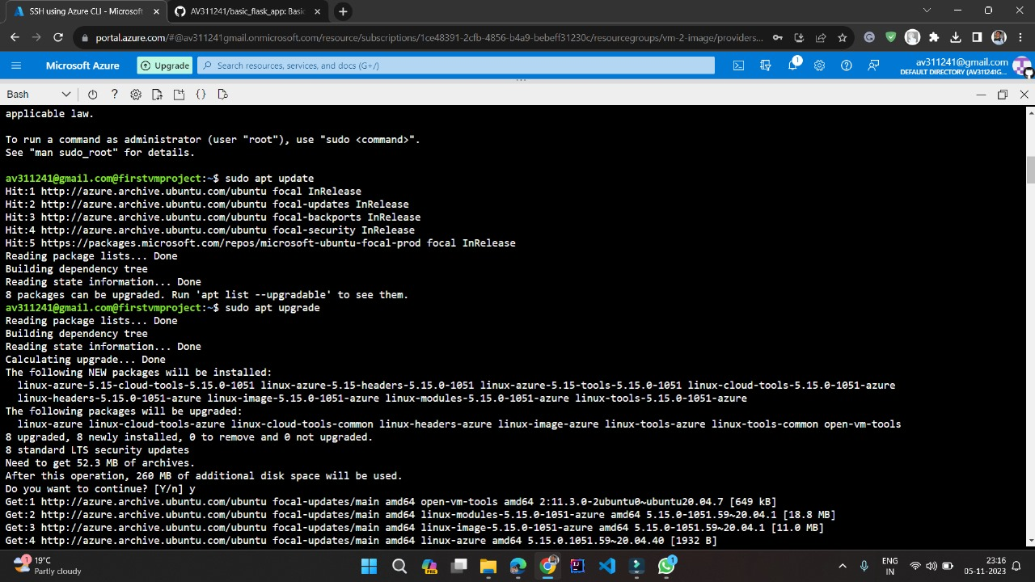sudo apt install python3 python3-pip git -y
3. sudo apt install msodbcsql17
4. mkdir app
5. cd app

**OPEN THE INBOUND PORT OF VM**

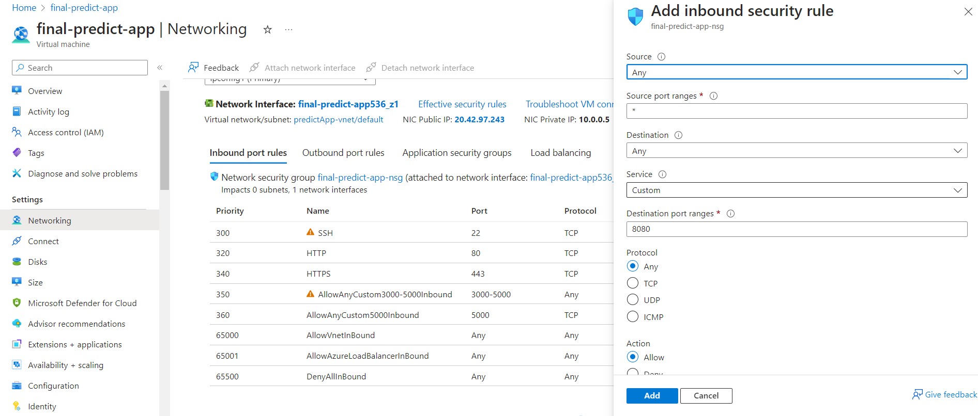

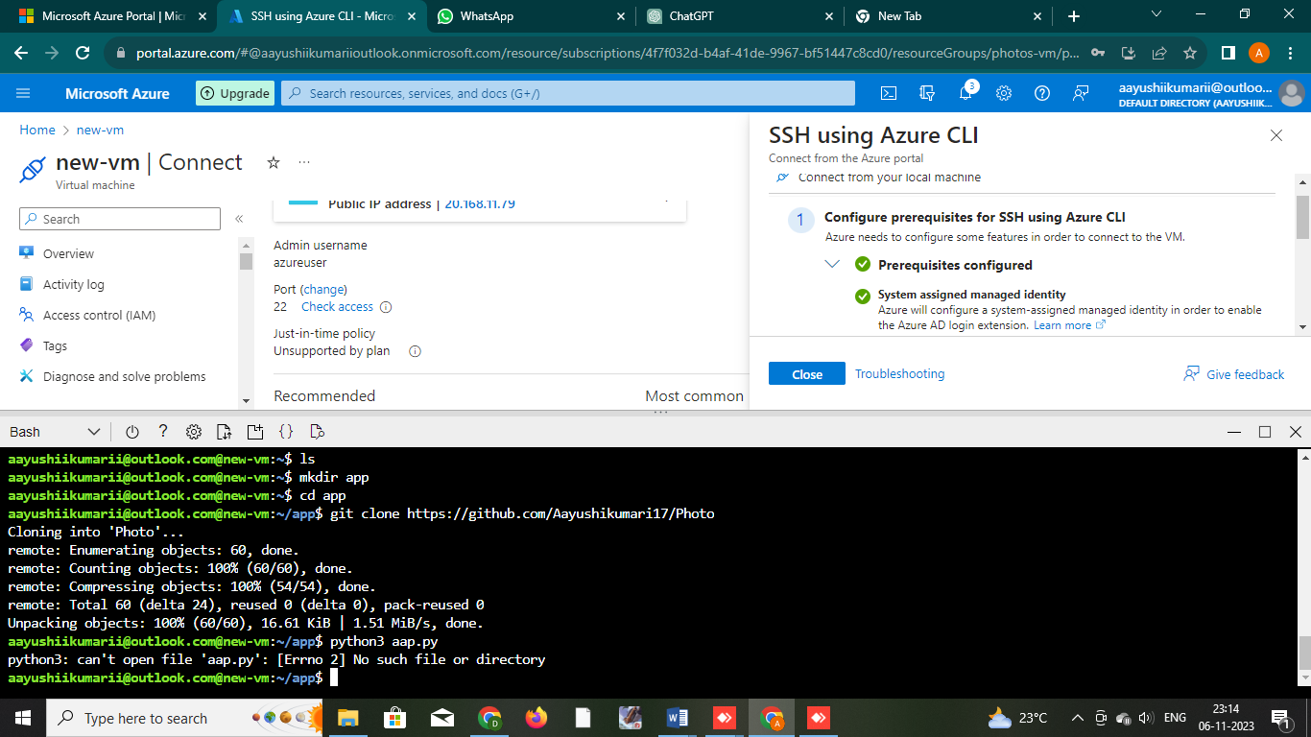**GIT CLONE**

Now the run the command python3 aap.py

**App Services**

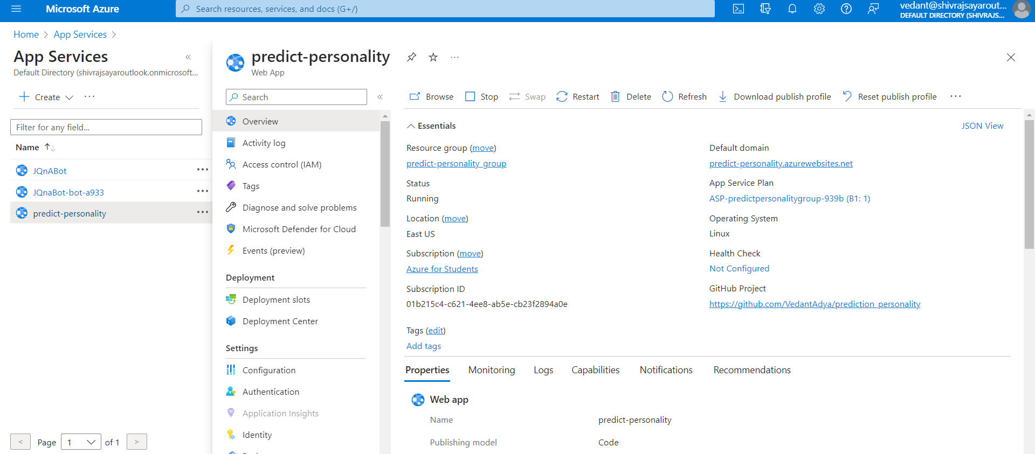

**OUTPUT**

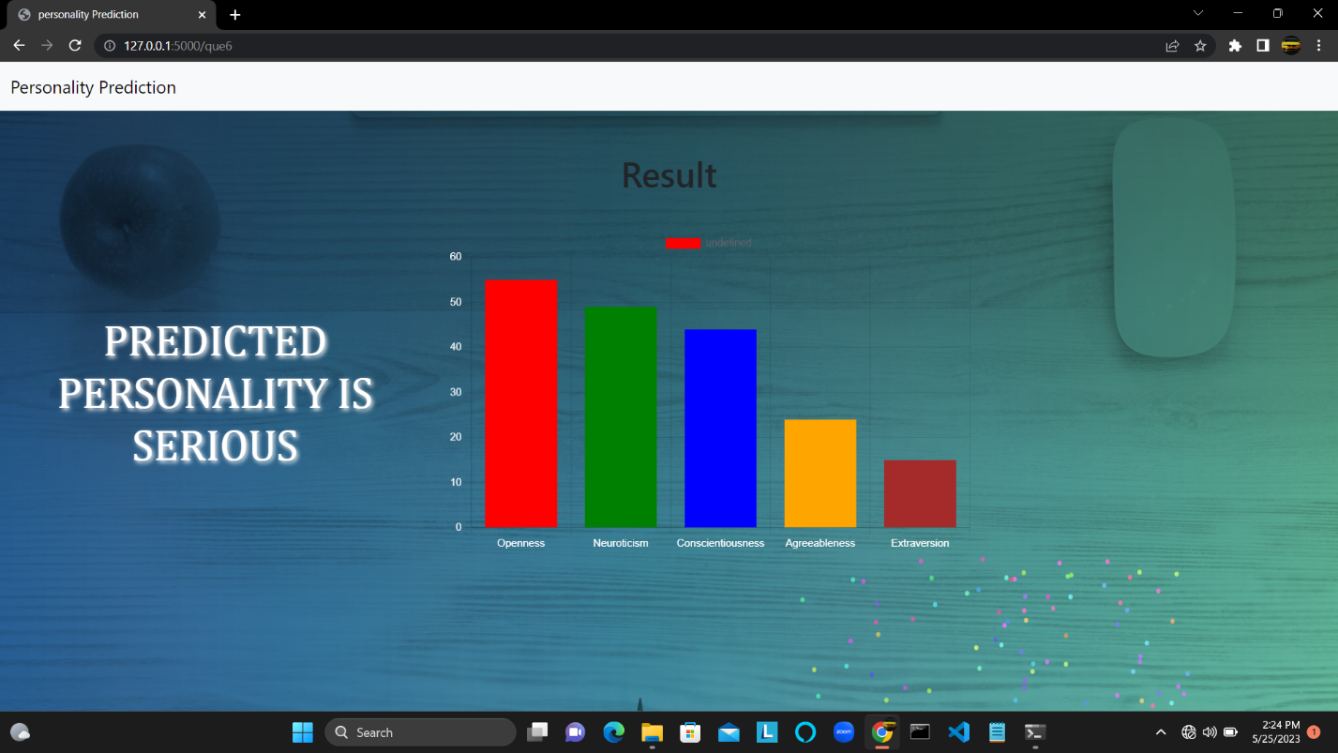

**SIGN UP**

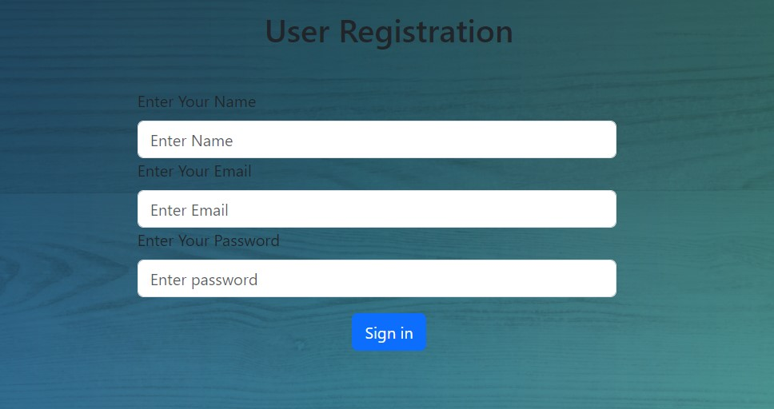

**LOGIN PAGE**

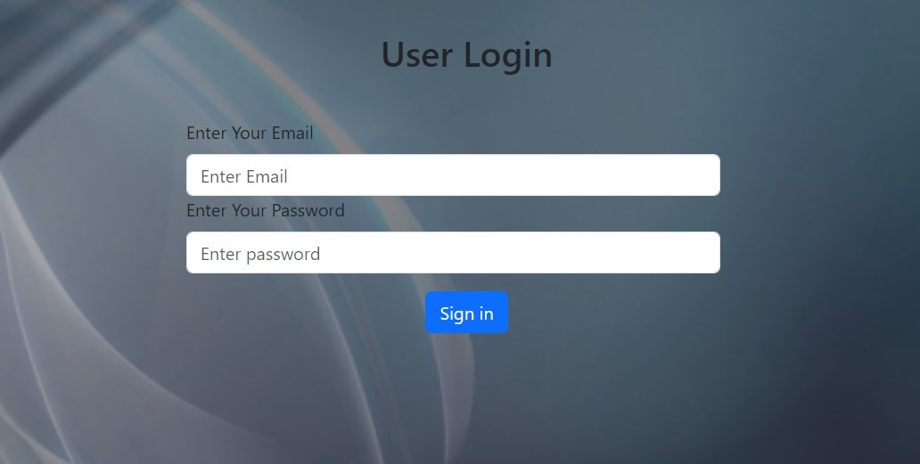

**QUESTIONSETS**

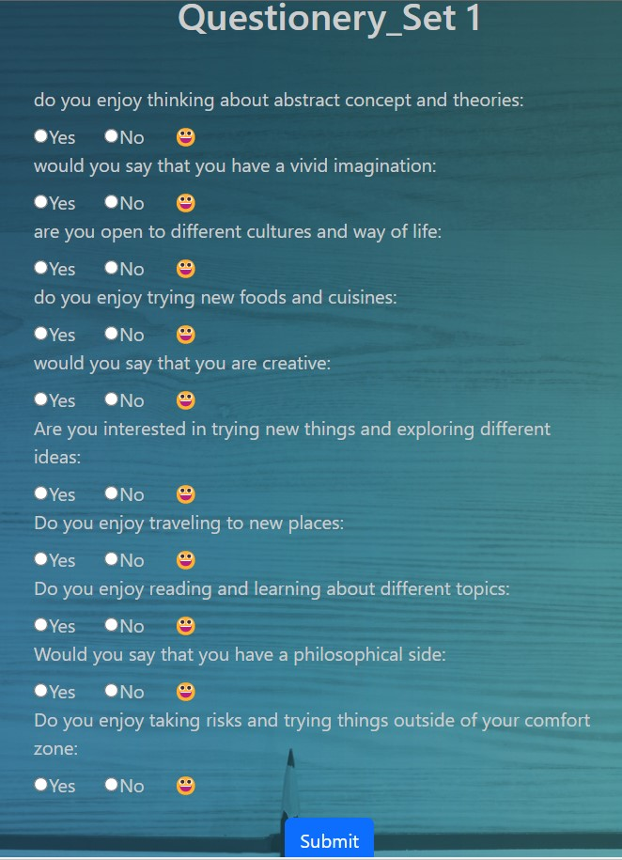 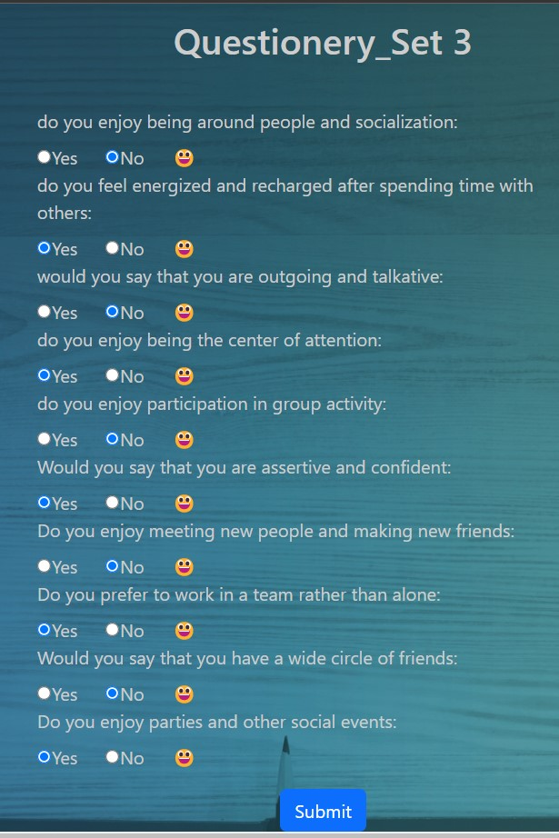

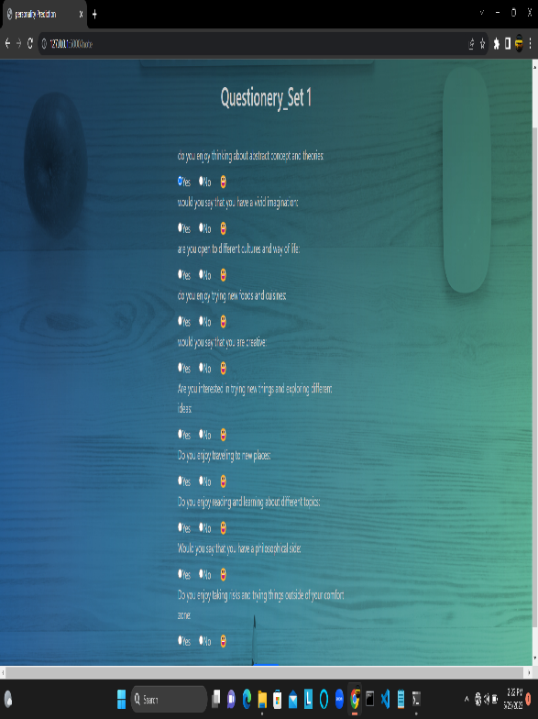 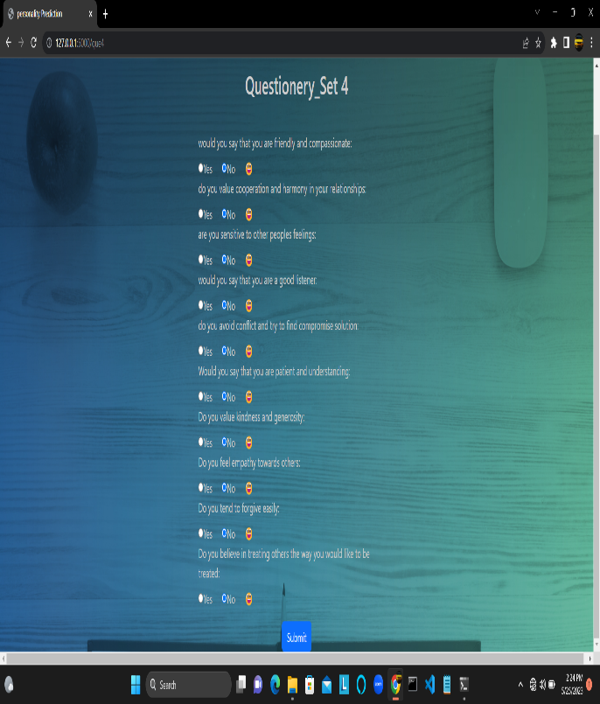

**Conclusion**

**Project Conclusion-**

* In conclusion, personality prediction based on the Big Five traits offers valuable insights into individual differences and behavior.
* Here we implemented our project.
* Personality identification of a human being by their nature an old technique. Earlier these were done manually by spending lot of time to predict the nature of the person.
* The goal of this project is to build a model that predicts the personality of the people is achieved.